FRONT COVER:

Terms and Conditions

LEGAL NOTICE

The Publisher has strived to be as accurate and complete as possible in the creation of this report, notwithstanding the fact that he does not warrant or represent at any time that the contents within are accurate due to the rapidly changing nature of the Internet.

While all attempts have been made to verify information provided in this publication, the Publisher assumes no responsibility for errors, omissions, or contrary interpretation of the subject matter herein. Any perceived slights of specific persons, peoples, or organizations are unintentional.

In practical advice books, like anything else in life, there are no guarantees of income made. Readers are cautioned to reply on their own judgment about their individual circumstances to act accordingly.

This book is not intended for use as a source of legal, business, accounting or financial advice. All readers are advised to seek services of competent professionals in legal, business, accounting and finance fields.

You are encouraged to print this book for easy reading.

Table Of Contents

Foreword

Chapter 1:
Self Esteem

Chapter 2:
Get Out Of Your Comfort Zone

Chapter 3:
Be Different

Chapter 4:
Slow Up

Chapter 5:
Connect With Nature

Chapter 6:
Find Your Courage

Chapter 7:
Feel Hot!

Chapter 8:
Live Abundantly

Foreword

Travel lets us reinvent ourselves again and again. We simply open our eyes and hearts and modification happens. When you travel with your eyes and your mind open, you recognize that you're not the same individual you were when you left home. I recognized some time ago that travel had altered me. The scenery, the risky ventures, the individuals I met, the places I stayed, all altered me; all for the better.

How To Enrich Your Life Through Travel

Better Your Life By Connecting With Your Inner Gypsy

Chapter 1:
Self Esteem

Synopsis

Look for somebody you look up to, a historic or modern-day figure. Pick one quality you desire more of in your life.

Then plan one action on your next trip to further its development. Live passionately, in your activities, as your role model would.

Self Esteem Travel Suggestion

Lack of self worth is bound up in dark memories from the past. - Deepak Chopra.

Deepak Chopra is an Indian-American doctor, orator, and writer on Ayurveda, spirituality and mind-body medicine. Chopra was born in New Delhi, India. New Delhi is the capital city of Republic of India. It functions as the center of the Government of India and the Government of the National Capital Territory of Delhi. A vivacious melting pot, you’ll hear a muddle of slangs spoken in Delhi, the most usual being Hindi, English, Punjabi and Urdu.

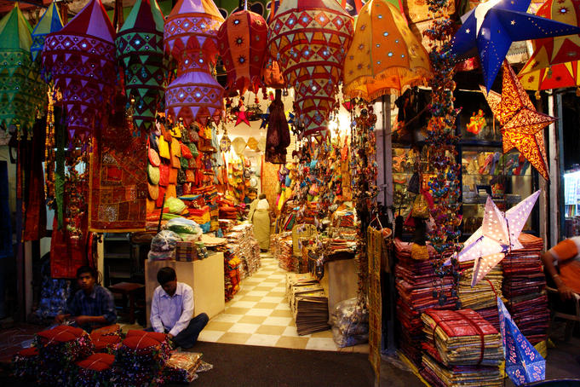

In terms of how it's laid out, Delhi has 2 really dissimilar worlds, the ‘old’ and the ‘new’, each delivering pleasurably different experiences. Roomy New Delhi was constructed as the imperial capital of India by the British people; unruly Old Delhi served as the capital of Islamic India. Visitors may easily dip into both, passing half the day plunging themselves in history at the spectacular Red Fort, Jama Masjid and medieval-flavored bazaars of Old Delhi, and the additional one-half renewing themselves over bubbling cappuccinos or frigid cocktails at one of New Delhi’s swank cafés and bars. Moreover, Delhi’s recent global culinary art revolution means that hungry travelers may now feast on everything from meaty Mughlai curries and fat South Indian idlis (rice cakes), to crisp wood-fired pizzas and squishy sashimi.

Think about these things while traveling to defeat low self-regard:

• Choose for yourself that it's time to be more self-assertive. By reaching out to other people you'll discover that you've a lot of things to offer to other people.
• Do not compare yourself to other people. Empathizing that you're different than other people, with another personality, will help you to see yourself unparalleled and special.
• Accept yourself; you're not perfect (so far). You are a work ongoing. You make errors like everybody else, but you're not a failure. Learn from misshapes, they're the most beneficial teachers. Find the seed of equal benefit in situations that fail and move on.
• Take compliments. They're your payment in your spiritual bank account.
• Attend seminars and self-help groups and get the support you need to establish your self-regard. Feed your mind and particularly your subconscious with favorable affirmation, and other great influences till this positive material sticks with you.
• Learn about your own notions and fundamental values. Toss out those which don't suit you any longer and build your belief around a couple of core values.
• Remain in contact with positive individuals at all times. It's crucial in building your self-regard, to surround yourself with positive individuals, music, info, words, and so forth. Constantly. To heal and recover your heart needs a lot of care.
• Be thankful. Grade yourself not on what you don't have but instead what you do have and what you've already achieved. Find what is correct in your life and be proud of it. Write it down, keep a blog or journal.
• Buy a few nice clothes and take care of your persona. Get some fragrance, buy some flowers; get a massage or whatever makes you feel great; love yourself.
• Invite help from family and acquaintances.

Chapter 2:
Get Out Of Your Comfort Zone

Synopsis

Add a muted risk to your future travel. You do not need to
Understand what the risk is; simply go with the aim that you will make one.
Then, at your destination, let the moment blossom. Explore a place or Action you’ve never went through before. Try one fresh thing every year.
Travel Ideas For Risk Taking

The most democratic tourist destination in El Norte Grande (and perhaps all of Chile), San Pedro de Atacama sits in the middle of some of the most breathtaking scenery in the country-the core of the Atacama Desert and can provide some exhilaration.

A chain of towering volcanoes, some of which are still alive, keeps guard to the east. To the west is La Cordillera de Sal, a chain of mountains compiled almost entirely of salt. Here you’ll find such wonders as the Moon Valley and the Death Valley, part of the Reserva Nacional los Flamencos.

The barren Salar de Atacama, Chile’s biggest salt flat, dwells to the south. The number of attractions in the Atacama area doesn't end there: alpine lakes, piping geysers, colonial villages, and ancient forts all lay within easy reach.

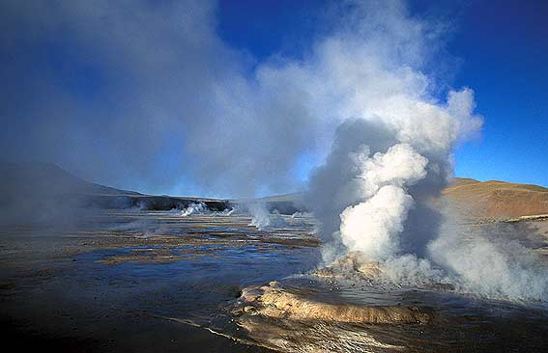

If you would like to alter anything in your life, you have to do something contrary to what you have been doing to get a different result.
The accompanying steps you are able to apply to your business, your personal life, your health, spiritualism, virtually any region of your life. It's up to you to make that change and make matters happen for you.

Set personal goals that are ambitious, that will help you grow as an individual. Your goals ought to inspire you so that you'll do whatever it takes to accomplish success. Dream huge and enjoy every moment of life.

Ask yourself: 'What may I be thankful for today?' Take little steps towards accomplishing your goals. Face your challenges and keep going taking relentless actions toward your goals.

Talk to individuals who are already doing what you'd love to do. Individuals love discussing how they accomplished success and the troubles they faced on their journey to success.

Chapter 3:
Be Different

Synopsis

Distinguish what is all-important to you. Draw out of the lines. Be different. Step away from your ‘normal’ behavior on your next travel. If you commonly follow, lead for a day. Go against your own convention. Think about one thing you'll be able to do tomorrow to touch, or relive, a childhood aspiration.

Unique Travel

How’s this for stepping out of the box…

Have you dreamed of exploring Australia, Africa or additional remote & exotic destinations? Of feeling the timeless, remote beauty of the "outback" or gazing at the wildlife of Africa? Now you are able to achieve your dream accompanied by individuals you know and trust - independent, but not solitary...

On a few safaris, you are able to drive your own - or a chartered - 4WD vehicle, and journey in the safety of a small convoy led by an adept guide. 4WD tuition is part of the package with some providers and no previous off-road experience is required. Pick from self-catering or participatory catering safaris with some providers as well. On additional adventures, you'll travel as a rider in comfy safari vehicles.
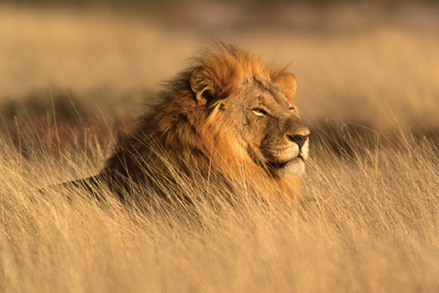
Rewind your spirit to childhood days and you'd realize how your experiences, notions, and events have left a lasting mark on your thinking blueprint. As you mature, little do you recognize that these experiences and notions become part of your interior personality and decide your future path of life? In order to have successful moves in life, you need to view the positive facets of your experiences. Yes hard but not impossible. At the end of the tunnel, most of the stale experiences gradually break down to fresh and positive ones.

Attitudes are essentially habitual reaction or response to other people based on your believing patterns and notions. These are based on the signals picked up from your senses and get evidenced in the thought process which changes in to beliefs and notions and get stored in your subconscious. These are basically responsible for structuring attitudes and habits. Attitudes are likewise an out come of preceding memories, genes, home environment, parenting and contents of interactions. You naturally have no control over your genes, culture, and society but you do have control of your thinking, notions and beliefs. You are able to mold these they way you like. It's said that 'winners do things differently'.

